**Final Cloud Engineering Assignment: Multi-Cloud Production-Ready Infrastructure**

**Title:** Designing & Deploying a Scalable Multi-Cloud Infrastructure  
 **Level:** Advanced (Final Project)  
 **Course:** Cloud Engineering

1. **Task 1: Infrastructure provisioning**

On Branch master

1. **Task 2: Flask-app deployment**

**Objective:** Deploy microservices with **Kubernetes, Helm, and Ingress.**

On branch flask-app

* After the infrastructures are provisioned
* Run terraform output -json > outputs.json
* Edit .env
* Run deploy.sh script

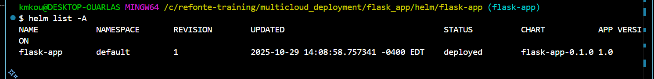



1. Test

**Setting helm repos:**

